 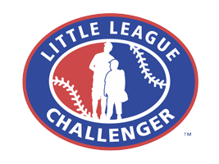

*Hamilton Fairfield Little League*

*Safety Plan*

*2020*



**Greg Ronquist Stephanie Chandler**

**President Safety Officer**

**League ID: 135-09-02**

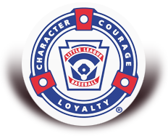

Contents

5INTRODUCTION 4

EMERGENCY CONTACTS 5

ADDITIONAL SAFETY-RELATED TELEPHONE NUMBERS 5

EMERGENCY PROCEDURES 6

FIRST AID 7

FOR MINOR SPRAINS AND CONTUSIONS, FOLLOW THE R.I.C.E. FORMULA: 8

ACCIDENT / INCIDENT REPORTING PROCEDURES 9

TRAINING 11

UMPIRES 11

EQUIPMENT 12

MANAGERS AND COACHES 13

Lightening Safety 16

CONCESSION STAND SAFETY 19

Appendix A 21

2019 Hamilton Fairfield Little League Board of Directors 21

Appendix B 23

Accident / Incident Report Form 23

Appendix C 25

Safety Checklist 25

Appendix D 27

Volunteer Application 27

Appendix E 38

Hamilton Fairfield Little League Fields 38

Appendix F 40

Little League Baseball and Softball Medical Release 40

Appendix G 42

2019 Umpire Evaluation Form 42

Appendix F 44

2019 Facility Survey 44

# INTRODUCTION

The mission of the Hamilton Fairfield Little League (HFLL) Safety Plan is to provide a systematic approach to promote the safety of all players, volunteers, and spectators. It focuses primarily on injury prevention through education of coaches and managers, player conditioning, health awareness, and proper maintenance of fields and equipment. When injuries do occur, this plan provides guidance on treatment and reporting procedures.

The Safety Officer prepared this Safety Plan with assistance of other members of the HFLL Board of Directors. Both the HFLL President and Safety Officer have registered with Little League International ASAP program and their information is on file in Williamsport, PA.

The Player Agent (Appendix A) will be submitting the player registration data, as well as coach and manager data via the Little League Data Center at [www.littleleague.org](http://www.littleleague.org).

This Safety Plan will be posted on the HFLL web site at [http://www.eteamz.com/ehftybl/](http://www.eteamz.com/ehftybl/%20) and distributed to all board members, managers, coaches, and umpire coordinators. A reference copy will also be placed in the concessions stand. Additionally, every manager of every team will be provided a copy to retain in their equipment bag for the duration of the year. Finally, this Safety Plan will be submitted to Little League International along with the 2019 Safety Plan Registration Form.

Safety is everyone’s responsibility. Parents are urged to discuss any practice or game-related safety concerns with their child’s team manager, coach or the Vice President of their child’s league. (See Appendix A for a complete list of all HFLL Board Members, including VP’s). Any issues that cannot be readily resolved should be raised to the attention of the Board of Directors through the Safety Officer. Additionally, a Safety Suggestion Box will be available where anyone may make recommendations for HFLL. We encourage your suggestions.

Managers and coaches-please review this plan carefully and follow it closely. If you have any questions, concerns, or suggestions, please discuss them with your league VP or the Safety Officer, as appropriate. Remember, if we are following and enforcing the rules outlined by Little League, we will have a very safe and successful season. Complete contact information is included in Appendix A.

***Let’s all have a safe season!***



# EMERGENCY CONTACTS

1. **In any police, fire, or medical emergency, dial 911 first**

Do NOT use the non-emergency numbers listed below. Identify your location as Crawford Woods Park. In the unlikely event that no cell phone is available, a land-line telephone is located inside the equipment garage at the HFLL complex.

2. **Notify a parent or guardian**

For medical emergencies involving a player or other child, notify their parent(s) or

guardian. Each team manager must maintain a list of emergency telephone contacts for every player on his/her team and have it readily available during all team games and practices. It is recommended that these numbers be added to each manager/coach’s cell phone contact list.

3. **Notify the League President or the Safety Officer**

Every emergency resulting in a 911 call or any other event that could reasonably result

in filing an insurance claim, must be reported (via phone) to either the League President (Scott Edmonds) or the Safety Officer (Scott McLaughlin) as soon as possible but not later than 48 hours after the incident occurs. An Accident / Incident Report Form must be completed and placed in the Safety Suggestion Box located near the concessions stand. The form is located in Appendix B of this Safety Plan.

## ADDITIONAL SAFETY-RELATED TELEPHONE NUMBERS

**Ambulance / Fire / Police 911**

Hamilton Police Department 513- 868-5811



Children’s Hospital Liberty Campus 513-803-9600



HFLL President 513-801-5705



HFLL Safety Officer 513-519-1070



# EMERGENCY PROCEDURES

1. In any medical emergency involving a player, volunteer or spectator **dial 911 immediately.**

2. Medical emergencies include, but are not limited to:

a. loss of consciousness or severe head trauma

b. an injury that could reasonably include spinal injury or paralysis c. signs of heart attack or stroke (heat)

d. compound fractures (broken bone penetrating the skin)

3. For serious injuries that do not constitute emergencies, the team manager should consult with the parent or guardian, if possible, to determine the preferred course of treatment.

4. If no parent or guardian is available, err on the side of caution by calling 911 for professional assistance.

**SIGNS OF HEART ATTACK:**

**SIGNS OF STROKE:**

 An uncomfortable feeling of pressure, squeezing, fullness, or pain in the center of the chest that lasts more than a few minutes, or comes and goes

 Discomfort in the left or both arms, the back, neck, jaw, or stomach

 Shortness of breath, which often occurs with or before chest discomfort

 A feeling of nausea, light-headedness, fatigue, or a sudden, cold sweat

 Sudden numbness or weakness of the face, arm or leg, especially on one side of the body

 Sudden confusion, trouble speaking or understanding

 Sudden trouble seeing in one or both eyes

 Sudden trouble walking, dizziness, loss of balance or coordination

 Sudden, severe headache with no known cause

Any incident involving a call to 911, or any other incident requiring professional medical care that could result in filing an insurance claim, must be reported (via phone) to either the League President (Scott Edmonds) and the Safety Officer (Scott McLaughlin) as soon as possible but not later than 48 hours after the incident occurs. An Accident / Incident Report Form must be completed and placed in the mailbox located near the concessions stand, and is included in Appendix B of this Safety Plan.

# FIRST AID

***Training***

1. Hamilton Fairfield Little League provides annual first aid training as outlined in this manual for managers and coaches.

2. Completion of training by at least one manager or coach from each team is MANDATORY.

3. In addition, each manager or coach must attend the training at a minimum every three years.

4. This training includes information on proper stretching, warm-up, and baseball mechanics to prevent athletic injuries.

5. The training is an online first aid course. Completion certificates are required by the Safety Officer for proper record keeping.

***First Aid Kits***

1. Basic first aid kits have been purchased and distributed to every team.

2. First aid kits must be on hand for all practices and games.

3. It is particularly important that team managers comply with this requirement when conducting practices at sites other than the Hamilton Fairfield Little League complex.

4. When at the HFLL complex additional first aid supplies are available inside the concession stand.

5. The league maintains a large supply of chemical ice packs in the concession stand.

6. Team managers should never begin a practice without at least two ice packs on hand.

*Medical Release Forms*

1. Mangers are responsible to have a completed Medical Release form (Appendix G) for every player.

2. Completed forms are to be kept in the protective sheet provided at the end of the safety manual in the event of an emergency at a practice or game.

***First Aid Tips***

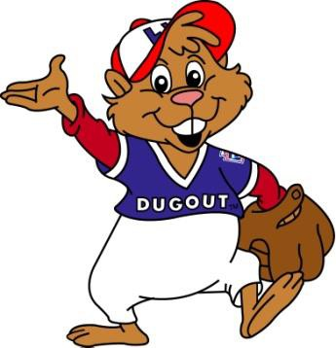**FOR MINOR CUTS/ABRASIONS:**

 Place clean absorbent bandage over wound and apply light pressure to control bleeding.

 Clean with warm, soapy water. If water is not available use antiseptic wipe from first aid kit.

 Apply antibiotic ointment and a clean dry bandage.

 Make sure that the injured person has current tetanus vaccination (10 yrs. for minor wounds.

**FOR BEE STINGS:**

Difficulty breathing and swallowing, swelling of the tongue, dizziness and fainting are all signs of a severe allergic reaction – **call 911 immediately if these symptoms occur.**

If no allergic reaction:

 Remove the stinger by pulling it straight out with clean tweezers

 Apply ice pack for 20 minutes

 Apply hydrocortisone cream to relieve itching

## FOR MINOR SPRAINS AND CONTUSIONS, FOLLOW THE R.I.C.E. FORMULA:

**Rest:**

**Ice:**

Do not allow player to return to activity unless he/she can do so without noticeable pain or favoring the injured area

Ice the injured area for 20 min.

**Compression:**

Apply light compression to reduce swelling and internal bleeding. Wrap the area

with an elastic bandage. (May wrap over ice pack.)

**Elevation:**

Elevate area above the heart to minimize pooling of blood.

# ACCIDENT / INCIDENT REPORTING PROCEDURES

***What to report***

1. Report ***ANY*** accident / incident that requires first aid or professional medical treatment, whether rendered on or offsite, to the Safety Officer.

2. Report “near misses” to assist the HFLL Board in identifying potential areas of concern to avoid any future injuries.

3. For injuries to players, the team manager is responsible for filing the report.

4. For injuries to volunteers or spectators, any league official who renders assistance should file the report.

***How and when to report***

1. Complete the Accident / Incident Report Form located in Appendix B of this Safety Plan.

2. All sections of the form should be completed.

3. In the event of an emergent situation, ensure that the contact information is completed prior to placing them in the Safety Mailbox located near the Concessions Stand.

4. Incidents should be reported to the Safety Officer as soon as possible but ***no later than 48 hours after they occur*.**

***Incident follow-up by the Safety Officer***

1. Within 48 hours of receiving an incident report, the Safety Officer will contact the injured party or his/her parents to:

✓ Check on the status of the injured party

✓ Verify the information received in the incident report

✓ Obtain supplemental information as necessary

2. In the event that the injured party required professional medical treatment, advise the parent of Hamilton Fairfield Little League’s insurance coverage and the procedures for submitting claims. The Safety Officer will make periodic follow-up calls, as necessary, until the incident can be considered closed.

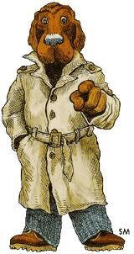

VOLUNTEER BACKGROUND CHECK

1. All Hamilton Fairfield Little League volunteers whose duties include working

with or supervising the activities of children must complete the volunteer application form shown in Appendix D.

2. That form, along with a photocopy of a valid driver’s license, must be provided to the

Safety Officer.

3. The Safety Officer will complete a national criminal and sex offender background check for each volunteer.

4. Any person who has been convicted of any sex crime, appears on any list of sex offenders, or has been convicted of any felony offense shall be prohibited from serving in any volunteer capacity with the league.

5. Any person who refuses to submit a complete volunteer form for any reason shall also be prohibited from volunteering.

6. Volunteers who  **must** undergo background checks include:

a.  **ALL** members of the Board of Directors

b. Managers

c. Team parents (Any parent assisting with practices must submit a request to the Board President via Volunteer Application as well as a copy of their Driver’s License for identification BEFORE providing service to the team or HFLL.

d. Umpires

e. Hired Workers

7. Other volunteers (including concessions stand workers, and field maintenance personnel)

will not routinely be required to submit the volunteer application.

8. The HFLL Board of Directors reserves the right to request a completed application and to run a background check on any volunteer.

9. The League Vice President shall provide a complete list of managers and coaches in their league to the Safety Officer for verification that background checks have been completed. The Safety Officer will conduct the background checks and will report results directly to the League President.

10. Until the Safety Officer certifies that a background check has been completed for a given volunteer, that person may not serve as a manager, coach, or volunteer helper in any HFLL practice or game. There are no exceptions to this rule.

11. HFLL reserves the right to prohibit volunteer service for other offenses identified in the background check that the Executive Committee feels may pose potential risk or harm to the players, other coaches or spectators of HFLL.

12. Volunteer forms and results of background checks will be retained for the year by the

HFLL Safety Officer.

# TRAINING



***Baseball Fundamentals***

1. Teaching proper baseball skills and techniques to young players enhances their enjoyment of the game while promoting player safety. Toward that goal, Hamilton Fairfield Little League provides mandatory training for all coaches and managers. Training will cover all aspects of running an effective practice, including hitting, sliding, fielding, pitching, proper stretching, and warm-up. All coaches and managers are encouraged to attend this excellent clinic.

2. **Attendance by at least one manager or coach for each team in MANDATORY.**

3. Each manager or coach must attend this training **every year**.

4. The Board of Directors will also prepare and distribute coaching manuals that are geared toward each age group. The manuals will outline appropriate training goals and techniques. Coaching manuals will be distributed prior to the start of spring practices.

COACHES CLINICs ARE SHEDULED FOR: 2/15/2020

# UMPIRES

1. All umpires are required to use the following safety equipment:

✓ chest protectors

✓ shin guards

✓ masks (with and without helmet)

✓ Male umpires must wear a protective cup.

# EQUIPMENT



1. The league’s equipment manager will inspect all helmets, catcher’s gear, and bats prior to the start of the season.

2. Managers and/or coaches should inspect equipment prior to each game using the Safety Checklist in Appendix C.

3. **Never allow a player to use defective or improperly fitting equipment!**

4. Repair damaged equipment if possible. Ensure all equipment is inspected thoroughly, including break-away bases to ensure they are in proper working order.

5. If you are not able to complete the repair, return the equipment to the Equipment Manager for repair or replacement by placing it in the Concessions Stand and notifying the Equipment Manager using the contact information in the Safety Plan.

6. Damaged equipment that cannot be repaired (e.g., cracked helmets or bats) shall be immediately removed from service and, if possible, physically destroyed to prevent their subsequent reuse by others.

7. All damaged equipment will be identified by the equipment manager and reported to the

Board of Directors.

**FACILITY SURVEY**

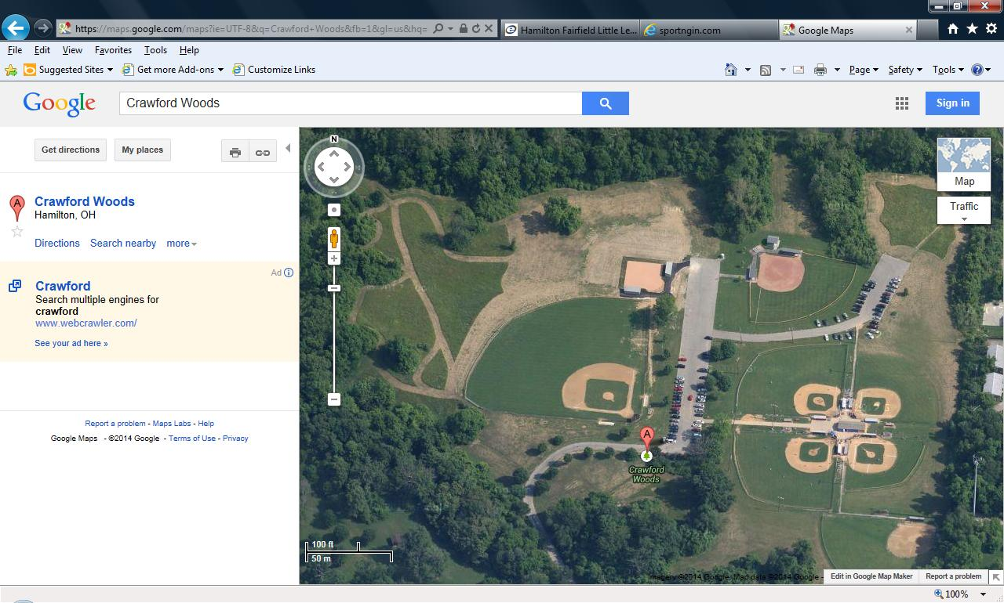

1. An electronic copy of the Little League Facility Survey has already been transmitted to the Little League Data Center. A hard copy is provided

for informational purposes only in Appendix D.

If anyone becomes aware of any deterioration in

facility conditions during the season that could

pose a safety hazard, they should raise those

concerns to the Safety Officer. (See Appendix A)



# MANAGERS AND COACHES

 Managers and coaches are the individuals primarily responsible for ensuring the safety of the players. The following procedures should be practiced until they become a routine part of your practice and game day activities.

**1. Game and Practice Activities**

a. **Prior to each game or practice, the manager or coach is responsible for walking the field looking for unsafe conditions. A Safety Checklist must be completed and placed in the mailbox located near the concessions stand, and is included in Appendix C of this Safety Plan.**

This might include broken glass or other foreign objects, holes in the ground,

damaged fences, etc. Necessary repairs should be completed before allowing a game or practice to begin. If repairs are not possible prior to a scheduled game, that game must be postponed and the Safety Officer (see Appendix A) notified immediately.

All dirt surfaces should be reasonably smooth and free of holes or other conditions likely to cause “bad hops.” If necessary, rake or drag the dirt to level the surface. (This should have been done after the preceding game.)

b. **Do not allow players to throw baseballs or swing bats in any off-the-field locations that could endanger other players or spectators**

Such warm-ups, when necessary, should be conducted away from pedestrian and

spectator areas. Be especially aware of the potential consequences of an overthrown ball.

c. **Inspect equipment for signs of damage that would make it unsafe**

Each team should have at least 6 helmets or various sizes on hand. Inspect the

helmets for cracks or inadequate padding. Unsafe helmets should be destroyed. Notify the equipment manager so that replacements may be obtained as necessary.

d. **Ensure that catcher’s equipment is in good condition and that all male catchers are wearing protective athletic cups**

Catcher’s mask must include a dangling throat protector. Ensure that the catcher

wears the mask during pre-game batting practice and when warming up pitchers, as well as during the game. Pursuant to Rule 3.09, Managers and Coaches are not allowed to catch pitchers; this includes standing at backstop during practice as informal catcher for batting practice.

e. **Ensure that all jewelry is removed by players**

No jewelry of any kind may be worn during games and practices. This includes neck

chains, earrings, rings, bracelets, and plastic “Livestrong”-type wristbands. Encourage players to leave all jewelry at home.

f. **Include at least 10 minutes of progressive warm-up time prior to each practice or game**

Players arriving late should be required to warm up properly before participating in

practice or game activities. Suggested warm-up activities include light jogging followed by light throwing at progressively greater distances.

g. **Ensure that a first-aid kit and a list of emergency telephone numbers for each player are on hand!**

HFLL recommends that a complete list of emergency contact telephone numbers be

stored in each manager and coach’s cell phone for the duration of the season.

h. **Keep players well hydrated**

Especially in hot weather, give the players frequent “water breaks” during practices.

During games, encourage players to drink plenty of fluids while in the dugout during the offensive half or the inning. Fluid intake should be limited to water or sports drinks for proper hydration. Food should not be allowed in the dugout.

i. **After the game, the home team must drag and rake all infield dirt areas**

The visiting team must pick up any trash left behind in the area of the field, empty

trash containers, and place clean trash bags in the containers. Both teams must clean all trash from their dugout/bench area.

C:\Users\Scott\AppData\Local\Microsoft\Windows\Temporary Internet Files\Content.IE5\AH77674H\MC900445184[1].wmf

**2. Bat Safety**

a. Little League regulations (Rule 3.09) prohibits practice swings by “on-deck” batters during games. Managers and umpires must strictly enforce this requirement. This prohibition includes the fenced-in in areas adjacent to

the dugouts where bats, helmets, and other equipment are typically stored. Additionally, coaches are not allowed to catch pitchers (Rule 3.09); this includes standing at backstop during practice as an informal catcher for batting practice.

b. Bats should never be allowed in the dugout while a game is in progress.

c. Only players and coaches should be in the dugout area during games and practices.

Any other individuals must stay in the spectator area.

d. At no time should bats ever be swung in any area other than the playing field, batting cage, or other area set up by and directly supervised by a manager or coach for instructional purposes (e.g., batting tee or “soft toss” station).

**3. Pitch Counts (Boys Minors, Majors, Juniors, and Seniors *ONLY*)**

a. Hamilton Fairfield Little League will be utilizing pitch counts as outlined in the Little League manual for 2020:

Pitchers league age 14 and under must adhere to the following rest requirements:

• If a player pitches 66 or more pitches in a day, four (4) calendar days of rest must be observed

• If a player pitches 51-65 pitches in a day, three (3) calendar days of rest must be observed.

• If a player pitches 36-50 pitches in a day, two (2) calendar days of rest must be observed.

• If a player pitches 21-35 pitches in a day, one (1) calendar days of rest must be observed.

If a player pitches 1-20 pitches in a day, no (0) calendar day of rest is required. The following

exception has been added to the “days of rest” requirement:

**EXCEPTION:** If a pitcher reaches a day(s) of rest threshold while facing a batter, the pitcher may continue to pitch until any one of the following conditions occurs: 1. That batter reaches base; 2. That batter is retired; 3. The third out is made to complete the half-inning. The pitcher will only be required to observe the calendar day(s) of rest for the threshold he/she reached during that at-bat, provided that pitcher is removed before delivering a pitch to another batter.

Pitchers league age 15-18 must adhere to the following rest requirements:

• If a player pitches 76 or more pitches in a day, four (4) calendar days of rest must be observed

• If a player pitches 61-75 pitches in a day, three (3) calendar days of rest must be observed.

• If a player pitches 46-60 pitches in a day, two (2) calendar days of rest must be observed.

• If a player pitches 31-45 pitches in a day, one (1) calendar days of rest must be observed.

• If a player pitches 1-30 pitches in a day, no (0) calendar day of rest is required.

b. Pitch count forms are provided at the back of this manual and are recommended to be used at every game.

c. The Manager, Coach, or parent volunteer should be selected to keep the pitch count

numbers on this form if used.

d. HFLL recommends verifying the pitch count number with the opposing teams pitch counter every half inning, to ensure an accurate number.

e. Forms are to be turned in after every game in the slot on the side of the garage next to the snack stand.

f. Pitch count summaries will be sent out to the Managers via the Player Agent identifying the summaries of all teams in the division and those players not eligible to pitch in the next game(s).

**4.** Questions or concerns regarding the accuracy of these numbers should be addressed with the Safety Officer.

**5. Trash**

a. After every game or practice, check field and dugouts for trash and place in field receptacles.

b. Empty or have someone on team empty trash after every game- into the dumpster located in the parking lot.

**6. Batting Cages**

a. Only managers, coaches or other responsible adults designated by the manager may pitch batting practice in the batting cages.

b. All batters must wear helmets.

c. Only one player may be in the batting cage at a time (except when picking up balls). d. Do not allow anyone to “hang on” to the fence such that fingers could be injured by a

batted ball.

e. No horseplay of any kind should be tolerated when using the batting cages.

f. Those using the cages must ensure the gate is closed and latched when in use and upon leaving.

**7. Pitching Machines**

a. Under no circumstances may anyone other than a manager or coach who has been trained, operate pitching machines.

b. Deliver at least 5 pitches with the machine to verify proper alignment prior to allowing players to bat.

# Lightening Safety

a. No practice or game should begin if lightning “bolts” can be

seen or if thunder is plainly heard.

b. Once the game is underway, responsibility for suspending play rests with the umpire-in-chief.

c. Both managers must remain acutely aware of an approaching storm and should notify the umpire immediately if lightning is seen or thunder is heard.

**d. If lightning is seen or heard, suspend activities immediately and direct all players to seek a safe shelter.**

e. When in doubt as to whether conditions are safe, the game should be suspended and the field and dugout areas should be cleared of all players and volunteers.

f. Use the “CLAP” method to determine the proximity of an approaching thunder and lightning storm. (EXAMPLE: Take note of the first lightening strike, count the seconds until thunder is heard and divide it by 5. If there is 15 seconds between lightening and the first clap of thunder, it can be estimated that the storm is 3 miles away. *(This information comes from the National Weather Advisory Bureau.)*

g. Since permanent shelter space is limited at the HFLL complex, everyone should take shelter in a hard-top vehicle with the windows up. Those for whom that is not possible should take shelter in the HFLL Bathroom Facilities.

h. No one should remain in the dugouts or any open area.

i. Lightning is highly unpredictable and can spread rapidly. j. If you are within 10 miles of lightning, you are in danger.

k. Ten miles is about the distance at which thunder can be heard under most atmospheric conditions.

l. If you hear thunder, you must suspend play.

m. Unusual atmospheric conditions can reduce the distance that thunder is heard to as little as 4 miles.

n. The absence of thunder cannot guarantee your safety.

o. If there are other signs (e.g., rapidly darkening sky and strong wind gusts) that a thunderstorm has approached to within 10 miles, you should suspend play.

p. All lightning produces thunder.

q. Lightning can be seen over much greater distances than thunder is heard.

r. So-called “heat lightning” (non-distinct flashes near the horizon that are not accompanied by any audible thunder) is simply lightning striking at a sufficient distance that the distinctive lightning bolt cannot be seen and no accompanying thunder is heard.

s. This indicates that a thunderstorm is active in the region and should promote increased vigilance for signs that the storm is approaching. However, it does not indicate that the storm is close enough to pose an immediate threat. Distant “heat lightning” alone, in the absence of other signs that the storm has approached within

10 miles, should not result in an immediate suspension of play.

**LIGHTNING FACT SHEET**

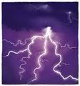

**Important Facts:**

✓ All thunderstorms produce lightning and are dangerous.

✓ Lightning often strikes outside the area of heavy rain and may strike as far as 10 miles from any rainfall. It is important to seek shelter well before the storm is upon you.

✓ **If you hear thunder, you are in danger.** Anytime thunder is heard, the thunderstorm is close enough to pose an immediate lightning threat.

**What To Do In Case Of Lightning:**

✓ If thunder is heard or lightning bolts are seen, suspend all activities immediately.

✓ Avoid open areas. Stay away from trees, towers, and utility poles.

✓ Stay away from metal bleachers, backstops and fences. Lightning can travel long distances through metal.

✓ **Do not allow players to remain in the dugouts or any open area.** Players, volunteers, and spectators should be directed to seek shelter in hard-topped vehicles with windows rolled up. Those for whom that is not possible should take shelter in the HFLL restrooms, avoiding corded phone lines, electrical wiring and plumbing.

✓ Activities should not resume until the “CLAP” method has been instituted.

**What To Do If Lightning Strikes Someone:**

✓ Lightning victims do not carry an electrical charge. They are safe to touch.

Move the victim to a safe area as soon as possible. Lightning can and does strike twice in the same spot.

✓ **Call 911 immediately.**

✓ Give first aid. Cardiac arrest is the immediate cause of death in most

lightning fatalities. If the victim is not breathing or does not have a pulse, an appropriately trained person should begin CPR until an ambulance arrives.

✓

# CONCESSION STAND SAFETY

**1. General Concession Stand Safety**

a. The concessions stand supervisor on duty should familiarize all volunteers /

employees with the location and operation of the fire extinguisher.

b. The concession stand supervisor is to be trained in safe food handling and/or preparation and procedures.

c. Children under the age of 16 are not permitted in areas around the grill or fryer when they are in operation or in a warm-up or cool-down mode.

d. Children under the age of 10 should not be in any area of the concessions stand.

Concessions stand volunteers / employees should make other arrangements for supervising their children.

e. A first-aid kit and ice packs are available in the concessions stand at all times.

**2. Cooks**

a. Wash hands before touching food or food containers.

b. Do not take more meat out of the freezer than what will be cooked within 15 minutes. c. Cook all hamburgers to well done.

d. Be careful when putting food into the fryer. Splashed or splattered grease can cause serious burns.

**e.** Cooks should wear a clean, white apron.

**f.** Make sure the fryer, grill, and coffee pot are turned off before closing the concessions stand.

**3. At Closing**

a. Clean counter tops with antibacterial cleanser.

b. Clean all cooking utensils in hot soapy water and place in rack to air dry. c. Discard any leftover cooked food in a sealed bag.

d. Empty trashcans to the outside dumpster and place clean bags in all cans.

**4. Counter Workers**

a. Wash hands before beginning work. Dry hands with paper towels, not dishtowels. b. Clean up spills, as they occur to prevent accidents. Re-wash hands after using any

cleaning product.

**c.** Place all trash in the trashcans. Do not allow clutter to build up.

# Appendix A

## 2020 Hamilton Fairfield Little League Board of Directors

**2020 Hamilton Fairfield Little League Board of Directors**

|  |  |  |  |
| --- | --- | --- | --- |
| President | Greg Ronquist | (513) 801-5705 | [president@hflloh.org](mailto:president@hflloh.org) |
| Vice-President | Travis Riley | (513) 256-6405 | [vicepresident@hflloh.org](mailto:vicepresident@hflloh.org) |
| Secretary | Doris Harkleroad | (513) 372-0711 | [secretary@hflloh.org](mailto:secretary@hflloh.org) |
| Treasurer | Megan Fishbough | (513) 708-5876 | [treasurer@hflloh.org](mailto:treasurer@hflloh.org) |
| Player's Agent | Adam Blundell | (513) 310-8717 | [pa@hflloh.org](mailto:pa@hflloh.org) |
| Safety Officer | Stephanie Chandler | (513) 519-1070 | [safety@hflloh.org](mailto:safety@hflloh.org) |
| Information Officer | Tracy Jordon | (513) 505-6797 | [info@hflloh.org](mailto:info@hflloh.org) |
| T-ball Director | Justin Fox | (513) 499-7806 | [t-ball@hflloh.org](mailto:t-ball@hflloh.org) |
| Coach Pitch Director | Cherish Herbers | (513) 614-2485 | [coachpitch@hflloh.org](mailto:coachpitch@hflloh.org) |
| Minor League Director | Justin Fox | (513) 499-7806 | [minors@hflloh.org](mailto:minors@hflloh.org) |
| Major League Director | Michael Herbers | (513) 869-3346 | [majors@hflloh.org](mailto:majors@hflloh.org) |
| Softball Director | Jeff Johnson | (513) 802-8043 | [softball@hflloh.org](mailto:softball@hflloh.org) |
| Umpire Coordinator | Greg Ronquist | (513) 801-5705 | [umpire@hflloh.org](mailto:umpire@hflloh.org) |

# Appendix B

## Accident / Incident Report Form

**HFLL ACCIDENT / INCIDENT FORM 2020**

|  |  |
| --- | --- |
| Name of Injured: | Date/Time: |
| Address: | |
| Phone: | Team/Manager: |

**Division in Which Accident Occurred:**

⇨ Junior ⇨ Majors ⇨ Minors ⇨ Challenger ⇨ T-Ball

**How Did Accident Happen?**

|  |  |  |
| --- | --- | --- |
| ***Struck By:*** | ***Collided With:*** | ***Other:*** |
| Pitched Ball | Fence | Tripped |

**Injury Type:**

|  |  |
| --- | --- |
|  |  |
| Batted Ball |  |
| Thrown Ball |  |
| Bat |  |

|  |  |
| --- | --- |
|  |  |
| Backstop |  |
| Hit Dirt too hard sliding |  |
| Umpire / Manager / Player |  |

|  |  |
| --- | --- |
|  |  |
| Fell |  |
| Over Exertion |  |
| Pre-Existing Med. Cond. |  |

|  |  |
| --- | --- |
|  |  |
| Face |  |
| Eye |  |
| Nose |  |

|  |  |
| --- | --- |
|  |  |
| Arm (R/L) |  |
| Wrist (R/L) |  |
| Finger (R/L) |  |

|  |  |
| --- | --- |
|  |  |
| Elbow |  |
| Upper Leg (R/L) |  |
| Lower Leg (L/R) |  |

|  |  |
| --- | --- |
|  |  |
| Foot (R/L) |  |
| Back (U/M/L) |  |
| Other: |  |

Head Ear (R/L) Thumb (R/L) Ankle (R/L)

|  |  |  |
| --- | --- | --- |
| **Unsafe Condition?**  Uneven field surface such as holes, humps, etc. | **Yes No** | |
|  |  |
| Foreign objects such as glass, rakes, stones, etc. |  |  |
| Congestion during practice or game |  |  |
| Weather conditions such as rain, sun, darkness |  |  |
| Poor Fitting protective equipment |  |  |

Other:

|  |  |  |
| --- | --- | --- |
| *Unsafe Acts?*  Mishandled ball | *Yes* **No** | |
|  |  |
| Mishandled bat |  |  |
| Poor evasive action |  |  |
| Incorrect sliding form |  |  |
| Not watching the ball |  |  |
| Awkward position |  |  |
| Player out of position |  |  |
| Lack of grip on bat |  |  |

Brief Statement of What Happened:

|  |  |  |
| --- | --- | --- |
| Poor running form | **Yes No** | |
|  |  |
| Wild pitch |  |  |
| Wild throw |  |  |
| Wild swing |  |  |
| Distracted |  |  |
| Lack of attention |  |  |
| Horseplay |  |  |
| Other |  |  |

⇨ No Treatment Needed ⇨ First Aide at Field ⇨ To Doctor ⇨ To Hospital ⇨ Other:

NOTE: This form is for Little League purposes only. When an accident happens- obtain as much information as possible. Send this form to the HFLL Safety Officer and he/she will forward it on to Little League Headquarters in Williamsport and the District Safety Officer. The reason for this form is to establish a record of all accidents prior to any lawsuits and to provide Little League Baseball, Incorporated and Hamilton Fairfield Little League with advanced information.

# Appendix C

## Safety Checklist

DATE:____________ Start Time: _______Finish Time:______ Field #: _______ Weather Conditions: ____________________

HFLL SAFETY CHECKLIST 2020

Person Completing Form: ____________________________________________________

In Good Repair- Have?

|  |  |  |  |
| --- | --- | --- | --- |
|  | **First Aid Yes No** | | |
| 23 First Aid Kit | |  |  |
| 24 Medical Release Forms | |  |  |
| 25 Injury Report Forms | |  |  |

|  |  |  |  |
| --- | --- | --- | --- |
|  | **Equipment Yes No** | | |
| 26 Batting Helmets | |  |  |
| 27 Bats | |  |  |
| 28 Athletic Cups (If catching-  Boys) | |  |  |
| 29 Shoes | |  |  |
| 30 Uniforms | |  |  |

In Good Repair-

. Have?

|  |  |  |  |
| --- | --- | --- | --- |
|  | *Field Conditions* **Yes No** | | |
| 1 Backstop | |  |  |
| 2 Home Plate | |  |  |
| 3 Bases | |  |  |
| 4 Pitcher’s mound | |  |  |
| 5 Grass Even (Infield) | |  |  |
| 6 Grass Even  (Outfield- L-C-R) | |  |  |
| 7 Outfield Fence | |  |  |
| 8 Warning Track | |  |  |
| 9 1st Base side Fence | |  |  |
| 10 3rd Base side Fence | |  |  |
| 11 Dirt Needed | |  |  |

|  |  |  |
| --- | --- | --- |
| **Dug Out (If Applicable) Yes** N  o | | |
| 12 Roof |  |  |
| 13 Walls |  |  |
| 14 Bench |  |  |
| 15 Bat Rack |  |  |
| 16 Trash Cans |  |  |

|  |  |  |  |
| --- | --- | --- | --- |
|  | **Catcher’s Equipment Yes No** | | |
| 17 Shin Guard (R) | |  |  |
| 18 Shin Guard (L) | |  |  |
| 19 Face Mask | |  |  |
| 20 Throat Protector | |  |  |
| 21 Chest Protector | |  |  |

Comments: (if areas above require additional explanation- Indicate number)

|  |  |  |  |
| --- | --- | --- | --- |
|  | *Other Safety Issues* **Yes No** | | |
| 31 Spectator Bleachers | |  |  |
| 32 Walk-Way | |  |  |
| 33 Score Board | |  |  |
| 34 Pitching Machine (Indicate  Number) | |  |  |
| 35 Grounds (Trees, rocks, etc) | |  |  |
| 36 Field Number Signs | |  |  |
| 37 So Swinging Signs | |  |  |

#

#

#

#

# Appendix D

## Volunteer Application

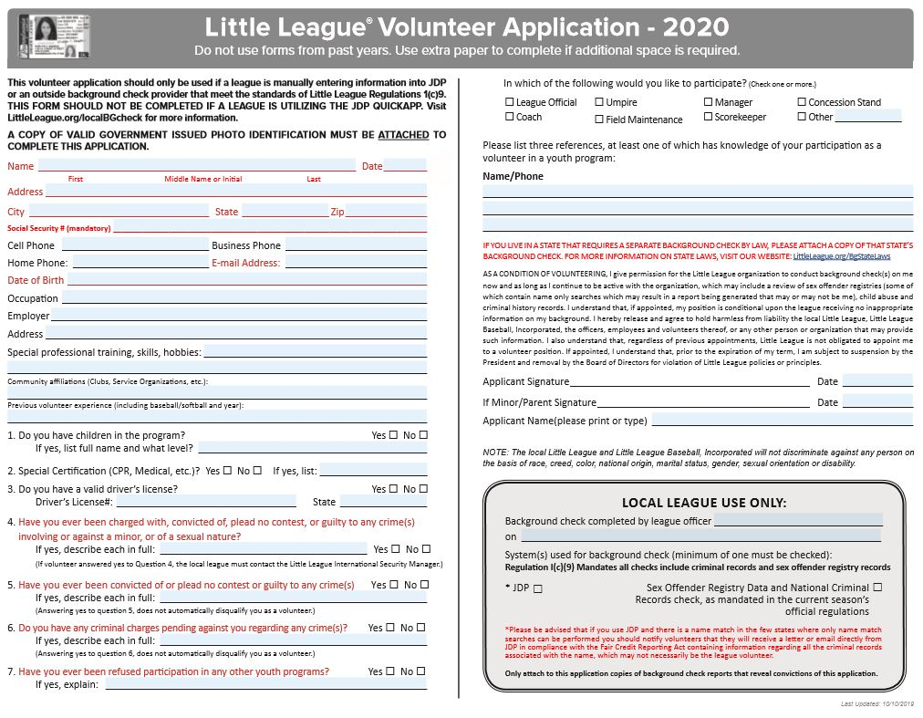

# Appendix E

## Hamilton Fairfield Little League Fields

**Prospect Fields at Crawford Woods**

**Hamilton, Ohio**



**1 2**

# Appendix F

## Little League Baseball and Softball Medical Release



# Appendix G

## 2020 Umpire Evaluation Form

***Place in***

UMPIRE EVALUATION FORM

(COMPLETE FOR EACH UMPIRE)

***Pitch Count Slot!***

It is Hamilton Fairfield Little leagues goal to constantly improve the quality of umpiring, and put the best umpire crews on the field whenever possible. In order to achieve this, we depend on the feedback from Managers and coaches regarding the performance of the umpires working their games. This has been a very informal process in the past; however, we would like to propose a more formal process and ask that the Managers and/or coaches take a more serious, objective and pro-active role in evaluating the performance of the umpires, with the goal to place the best umpires on the field for the playoffs.

In evaluating the performance of an umpire, the key points to consider should be knowledge of the rules, consistency, decisiveness, proper positioning and mechanics, and game management. We also encou rage additional comments to

complement the numeric ranking. We will share aggregated results with the umpires, while keeping your name confidential.

Thank you in advance for your cooperation in this process. Please let me know if you have any other commen ts or suggestions for improving the quality of umpiring at HFLL.

**Evaluated Umpires Name**

**Umpire Position:** PLATE BASE

**Division:**  Minors Majors Bigs

**Date of Game**:

Time of Game:

**Teams that Played:**  vs.

**GRADING SCALE:**

**Chec k O ne “X”**

1. Exceptional - Some may equal, but none will exceed

2. Very Good - Much better than required standards

3. Average - Meets required standards

4. Marginal - Does not entirely meet required standards

5. Unsatisfactory - Does not meet expected standards

|  |  |  |  |  |  |
| --- | --- | --- | --- | --- | --- |
| **Description** | **1** | **2** | **3** | **4** | **5** |
| Personal Appearance on the field (neatness & proper dress) |  |  |  |  |  |
| Knowledge of the rules |  |  |  |  |  |
| Judgment on the field (decisiveness & consistency) |  |  |  |  |  |
| Field Mechanics (proper positioning and timing) |  |  |  |  |  |
| Plate Mechanics (proper positioning and timing) |  |  |  |  |  |
| Control of the Game (Keep the game moving in a smooth manner) |  |  |  |  |  |
| Composure (Handling situations with players, coaches, etc.) |  |  |  |  |  |
| Attitude |  |  |  |  |  |

**GENERAL COMMENTS: ( including anything pertinent to Umpire’s Character or Personality)**

**Evaluator's name Print Name:**

**For Immediate concerns** - Contact Greg Ronquist at 513-801-5705

# Appendix F

## 2020 Facility Survey